Food Assistance Resources
While the Coronavirus pandemic is a frightening time for many of us, it is important to remember that we are in this together. San Diego’s hunger relief sector has information and resources to help you through your time of need.
While schools are closed, many are providing breakfast and lunch in a grab-and-go takeaway format.
• Meals are for all children ages 2-18, no verification, ID, or registration needed.
• Children must be present to receive the meals.
• Children to not have to attend a particular school to receive meals at that location.
Find a location serving meals for kids near you: bit.ly/youth-meals

Meals for Kids
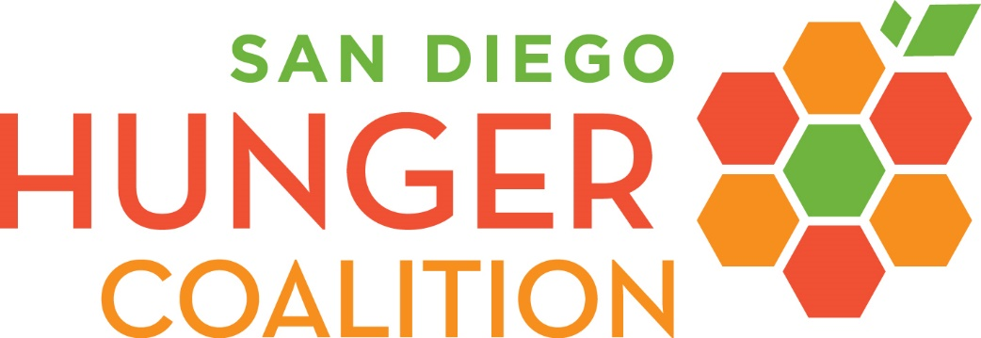
PLEASE NOTE: Many sites have transitioned to takeaway meals. We encourage you to call your dining site at least one (1) day in advance to find out if takeaway meals are available, and to reserve one for yourself.
You may call 1-800-339-4661 for assistance.
You may find contact info for meal providers at: bit.ly/senior-meals
Senior Congregate Meals
CalFresh (SNAP) will continue to operate as normal and is accepting new applications and renewals. Benefits will be received by enrollees as normal.
Individuals are encouraged to apply online at GetCalFresh.com, or over the phone by calling 2-1-1. You can also apply with a community-based organization. Find one at sdhunger.org/calfresh-assistance.
CalFresh (SNAP)
All San Diego WIC agencies are currently operating remotely. Most appointments and assistance will be provided over the phone. Go to sdhunger.org/covid19/#wic for a list of contacts.
For questions about which WIC agency to access, please go to sdwic.com.
WIC
Unless community members have heard otherwise from their local pantries, distributions will remain open during regularly scheduled hours. Please call 2-1-1 for additional information.
Community members may also contact Feeding San Diego at (858) 452-3663 or the Jacobs and Cushman San Diego Food Bank at (858) 527-1419.
Food Banks
More information is available at http://www.sdhunger.org/covid19.
Created 2020 by San Diego Hunger Coalition for use by its hunger relief partners.

