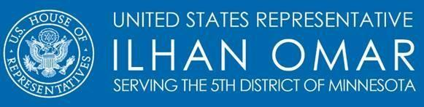
Suspend School Meal Debt
Sponsor: Rep. Ilhan Omar
To cosponsor the bill: tinyurl.com/Cosponsor-bill
To endorse the bill: tinyurl.com/Endorse-bill

According to the School Nutrition Association (SNA), the median amount of unpaid meal debt by school district across the US has soared 70 percent over the past six years. In just 2018, 75 percent of school districts reporting to SNA had unpaid meal debt ranging from $10 to $500,000. Often times, unpaid school meal debt results in students going hungry, experiencing lunch shaming at school by peers and school administrators, and places a lot of financial pressure on the family.

The Suspend School Meal Debt Act, would require that school food authorities and local educational agencies to not collect unpaid meal fees during the COVID–19 pandemic, providing the much-needed relief for families across the nation.

If the federal government doesn’t step up, this means the cost of unpaid school meals fall entirely on local districts, who are already facing harsh economic conditions.

This straightforward bill would:
- formally suspend the collection of all meal debt,
- suspend any late fees associated with such unpaid meals,
- cancel the meal debt for families and,
- require the Secretary of Agriculture to reimburse each school food authority and local educational agency.

While the cost of school meals widely varies depending on where you are in the US, a 2018 SNA study found that on average, school lunch costs $2.48 for primary schools and $2.74 for secondary schools nationwide, while the average breakfast costs $1.46 for primary schools and $1.55 for high schools. Though these amounts may seem low, but bills can add up quickly. A parent purchasing breakfast and lunch for one child can end up paying up to $770 per year, which is a significant amount for many low- and middle-income families in the US.

This bill would provide essential economic relief for families during the economic hardship caused by COVID-19 by reducing the stress and putting money into their pockets.

For more information, please contact Maria Martirosyan (Maria.Martirosyan@mail.house.gov).

